STAT 8101
Sampling Design and Analysis

Drivers of Unemployment in Canada:
A Focus on Demographic and Economic Factors



NAME: VIGNESH ARVIND
STUDENT ID: 47980737

Table of Contents
Declaration 3
Abstract 4
Introduction: 5
Data Description 6
• Key Features of the Dataset: 6
• Variable Types: 7
• Missing Data: 7
• Weighting: 7
• Survey Design and Nonresponse: 8
• Potential Uses: 8
Survey methodology 9
• Target Population 9
• Sampling Design 9
• Weighting 10
• Non-response to the LFS 10
Data Analysis 11
Discussion 16
• Gender Disparities in Employment Status: 16
• Educational Attainment and Earnings: 16
• Age and Income Levels: 16
• Nonresponse and Missing Data: 16
Conclusion 17
References 17

Declaration
I declare that this project is evidence of my own work and contributions. It has not been previously submitted for academic credit.

Date: 25th October, 2024

Abstract

Using information from Statistics Canada's Labour Force Survey (LFS), this paper examines unemployment trends in Canada. To guarantee representativeness across a range of demographic and geographic groupings, the LFS uses a stratified multi-stage sample methodology that incorporates survey weights and clustering. In order to account for the intricate survey design, this study uses design-based estimate methodologies to investigate the association between unemployment and demographic characteristics such as age, gender, education, and immigrant status.

To forecast the probability of unemployment based on demographic and economic factors, the study makes use of weighted descriptive statistics, a weighted logistic regression model, and a chi-square test for associations between categorical variables. The findings indicate that while immigrants face different unemployment risks, younger people and those with less education have far higher jobless rates depending on their years in Canada. The results highlight how crucial it is to use suitable survey weights and design modifications in order to prevent skewed estimates. This study also emphasises how economic factors, including industrial sector, influence labour force outcomes. The findings highlight the need of taking into consideration the intricate architecture of the LFS when drawing conclusions at the population level and offer solid, statistically sound insights into unemployment trends.

Introduction:

In order to construct trustworthy population-level conclusions and comprehend Canadian unemployment patterns, strong survey sample techniques must be used. Statistics Canada's Labour Force Survey (LFS), which employs a complex probability-based sampling design that includes stratification and clustering, is used in this study to efficiently capture labour market characteristics across Canada's diverse geographic and demographicscape. In order to construct trustworthy population-level conclusions and comprehend Canadian unemployment patterns, strong survey sample techniques must be used. Statistics Canada's Labour Force Survey (LFS), which employs a complex probability-based sampling design that includes stratification and clustering, is used in this study to efficiently capture labour market characteristics across Canada's diverse geographic and demographicscape.

The LFS's sophisticated sampling architecture, which uses a rotating panel design with careful consideration of design effects and sample weights, enables the examination of unemployment determinants while accounting for the survey's complex design aspects. This methodological approach is crucial since neglecting the survey design elements might lead to erroneous variance estimates and possibly misleading conclusions about unemployment trends in the Canadian population.
The purpose of this study is to:
Analyse unemployment trends with design-based estimating techniques that suitably account for the LFS's stratified multi-stage sample approach.
Examine the relationships between unemployment rates and demographic traits while accounting for appropriate survey weights and clustering effects.
Use weighted regression analysis that accounts for the complex survey design to investigate the relationship between economic conditions and unemployment.
To evaluate the precision of our estimations, choose appropriate standard errors that account for both stratification and clustering effects.

This study ensures that all results on the variables leading to unemployment are statistically sound and account for survey design features by employing the LFS's full sample record and suitable survey analysis procedures. The study will focus on unemployment trends in Canada to provide reliable population-level insights on design impacts, nonresponse adjustments, and appropriate variance estimation methodologies.
This technique solves real-world challenges in interpreting complex survey data while remaining true to the fundamental concepts of survey sampling theory. The findings will not only increase our understanding of the factors that drive unemployment, but will also demonstrate the need of adequate survey design for making population-level conclusions.

Data Description

This project's dataset comprises 111,645 observations and 60 variables, making it a valuable resource for a variety of demographic and labour force research. Given factors such as the survey year, month, and labour force status, it looks to be the result of a large-scale survey. The dataset has both integer and float values, suggesting a combination of categorical and continuous variables.

Key Features of the Dataset:

Number of observations (records): 111,645 Number of variables: 60
Types of variables: Both categorical (13 integer variables) and continuous (47 float variables) Core Variables:

REC_NUM (Record Number): This is a unique identifier for each record in the dataset. It helps maintain the uniqueness of each survey response.

SURVYEAR (Survey Year) and SURVMNTH (Survey Month):These variables provide the year and month in which the data were obtained, which is useful for time- based analysis or trend detection.

LFSSTAT (Labor Force Status): This categorical variable most likely represents the respondent's employment status, such as employed, unemployed, or out of the labour force. It is a significant factor in labour market analysis.

PROV (Province) and CMA (Census Metropolitan Area): These variables reflect geographic data. "PROV" codes most likely pertain to the respondents' province, whilst "CMA" codes denote the urban regions examined. These are essential for regional analyses.

AGE_12 (Age Group) and SEX (Sex): "AGE_12" divides respondents into age categories, whereas "SEX" indicates the respondent's gender. Both variables are necessary for demographic analysis.

MARSTAT (Marital Status): This variable categorises respondents based on their marital status, which can predict a variety of socioeconomic behaviours and job status.

EDUC (Education Level):This variable, which most likely indicates the respondent's greatest degree of schooling, is essential for comprehending the relationships between education and job outcomes.

IMMIG (Immigration Status): The respondent's immigration status is indicated by this variable, which may be used to compare the labour market results of immigrants and nonimmigrants.

FINALWT (Final Weight): In order to guarantee that the results are representative of the larger population, this survey weight variable corrects for sample design. It is necessary to adjust for over- or under-sampling of certain groups and to provide population-level estimates.

Variable Types:

Categorical Variables: Integer-coded variables such as "SEX," "PROV," and "LFSSTAT" denote different categories. Meaningful analysis requires decoding them using documentation or a codebook.

Continuous variables: "UHRSMAIN" (usual hours worked per week), "HRLYEARN" (hourly earnings), and "AGE_12" are important for researching labour trends since they enable more detailed analysis.

Missing Data:

The dataset has some missing data, particularly in the employment-related variables:
There is a substantial amount of missing data for AGE_6, another age variable, with just 21,988 non-null values out of 111,645. This implies that it may not have been gathered consistently or applied to every responder.
Large amounts of data are also lacking for variables like FTPTLAST (full-time or part-time status) and EVERWORK (if the respondent has ever worked), which may have an impact on labour market analysis.
While the data for some variables, including UNION (union membership) and HRLYEARN (hourly earnings), is more comprehensive, certain values are still missing, which may necessitate sensitivity analysis or imputation.
In order to prevent biassed results, it is crucial to take into consideration nonresponse or question skipping in the survey design, which might result in missing data.

Weighting:

One important component of this survey is the FINALWT variable. In addition to correcting for uneven selection probabilities, nonresponse, and other design-related variables, it takes into consideration the survey's design, including elements like stratification and clustering. We can get estimates that are typical of the target population by using this weight. This weight should be used in all analyses to account for sample biases and guarantee the representativeness of the survey.

Survey Design and Nonresponse:

Given the size of the dataset, it is probable that the survey included sophisticated sampling strategies, such as clustering (to lower data collecting costs) and stratified sampling (to guarantee representation across important subgroups). The use of survey weights implies these variables, even if they might not be stated clearly in the dataset. Accurate analysis depends on knowing how nonresponse is handled, whether by weighting changes or other methods, especially when some important areas include missing data.

Potential Uses:

This dataset may be used for a number of analyses, such as:

Examining the population's age, gender, and educational attainment distribution is known as descriptive analysis.
Examining employment trends across various demographic groups and geographical areas is known as labour force participation.
Regression analysis is the process of forecasting wages or labour force status using factors like education and immigration status.
Examining the reasons and consequences of missing data in important variables, particularly in domains pertaining to employment, is known as nonresponse analysis. In conclusion, the dataset provides a multitude of data on employment-related, regional, and demographic factors. For reliable and representative results, however, missing data and the appropriate use of survey weights need to be carefully considered.

Survey methodology

Target Population
The target population for LSF is the non-institutionalised population 15 years of age and over. The survey is conducted nationwide, in both the provinces and the territories.
The LFS excludes residents of institutions, as they are generally not economically active and unable to participate in the labour market. Full-time members of the Canadian Armed Forces are also excluded due to practical difficulties in sampling and interviewing, as many are stationed in inaccessible locations. Households in remote areas with very low population density are not included, as the effort and cost of reaching them outweigh the minimal potential bias. These groups together represent an exclusion of less than 2% of the Canadian population aged 15 and over.
The dataset used in this analysis includes only the provinces. Although labour force data is collected from the territories using the same questionnaire, a different
methodology is applied due to challenges like small, dispersed populations, higher costs, and logistical issues. Therefore, territorial estimates differ from provincial ones and are excluded from this analysis.

Sampling Design
The LFS is a cross-sectional survey with a probability sample based on a stratified multistage design.
Each province is divided into strata, which are geographic areas that are homogeneous with respect to key labour market variables (such as employment levels, income levels, etc.) and census metropolitan area (CMA) boundaries. The purpose of creating strata is to make sampling more efficient. For example, by dividing the population into these relatively homogeneous groups, it is easier to get accurate estimates for each group while maintaining stability in sample sizes across the regions. Some special strata are created to focus on specific sub-populations (e.g., high-income households or Aboriginal populations). However, these special strata are treated the same as other strata during the LFS sampling process.
A two-stage sampling approach is applied to all provinces except Prince Edward Island. Within each stratum, ‘clusters’ containing approximately 230 households are defined as small contiguous geographic areas. In the first stage of sampling, a number of clusters, typically six, are selected from each stratum. For each selected cluster, a list of its dwellings is created. In most clusters, the list is extracted from the Dwelling Universe File created and maintained by Statistics Canada. For clusters not covered by this file, using a map of the cluster, an interviewer visits the cluster and lists all dwellings. In the second stage of sampling, a sample of dwellings is drawn from these lists. Due to the specific characteristics of Prince Edward Island, a single stage sampling method is used where dwellings are selected directly from the list of address for each stratum.
The LFS uses a rotating panel sample design. Selected dwellings remain in the LFS sample for six consecutive months and may be contacted in advance of this period to confirm contact information. The total sample is divided into six representative sub-samples, or panels, with one panel being replaced each month after completing its six-month participation. The departing households are replaced by new ones from the same or a similar geographic area. This design creates a five-sixths overlap in
the sample from one month to the next, enhancing the efficiency of estimating month-tomonth changes. The six-month rotation ensures that households do not face an excessive
burden by limiting their participation in the survey.

Weighting
The sample data are weighted to produce estimates at national, provincial, and sub- provincial levels. There are a certain number of weighting factors to be used in the calculation of the individual weights.
Each household is assigned a basic weight, which is the inverse of its selection probability. This basic weight is adjusted for sub-sampling, non-response, and coverage errors. Nonresponse is addressed through imputation or by adjusting the weights of responding households, assuming they are representative of non- responding ones. The weights derived after the non-response adjustments are called the subweights.
The subweights are further modified to correct for coverage errors and reduce sampling variance through composite calibration, which improves efficiency by leveraging the overlap between consecutive samples. The integrated method ensures that each person in a household has a common final weight, aligning estimates with control totals.

Non-response to the LFS
Non-response to the LFS average about 10% of eligible households. Interviewers are instructed make every reasonable effort to secure interviews with eligible participants. If a household initially refuses, a letter is sent from the Regional Office emphasizing the survey's importance and requesting cooperation. This is followed by a second call or visit from the interviewer. If the initial contact is inconvenient, an appointment is scheduled for a more suitable time, and multiple follow-ups are made for cases where no one is home.
Sampled dwellings are never replaced due to non-response.
Each month, after all attempts to obtain interviews have been made, a small number of nonresponding households remain. A weight adjustment is applied to account for nonresponding households.

Data Analysis
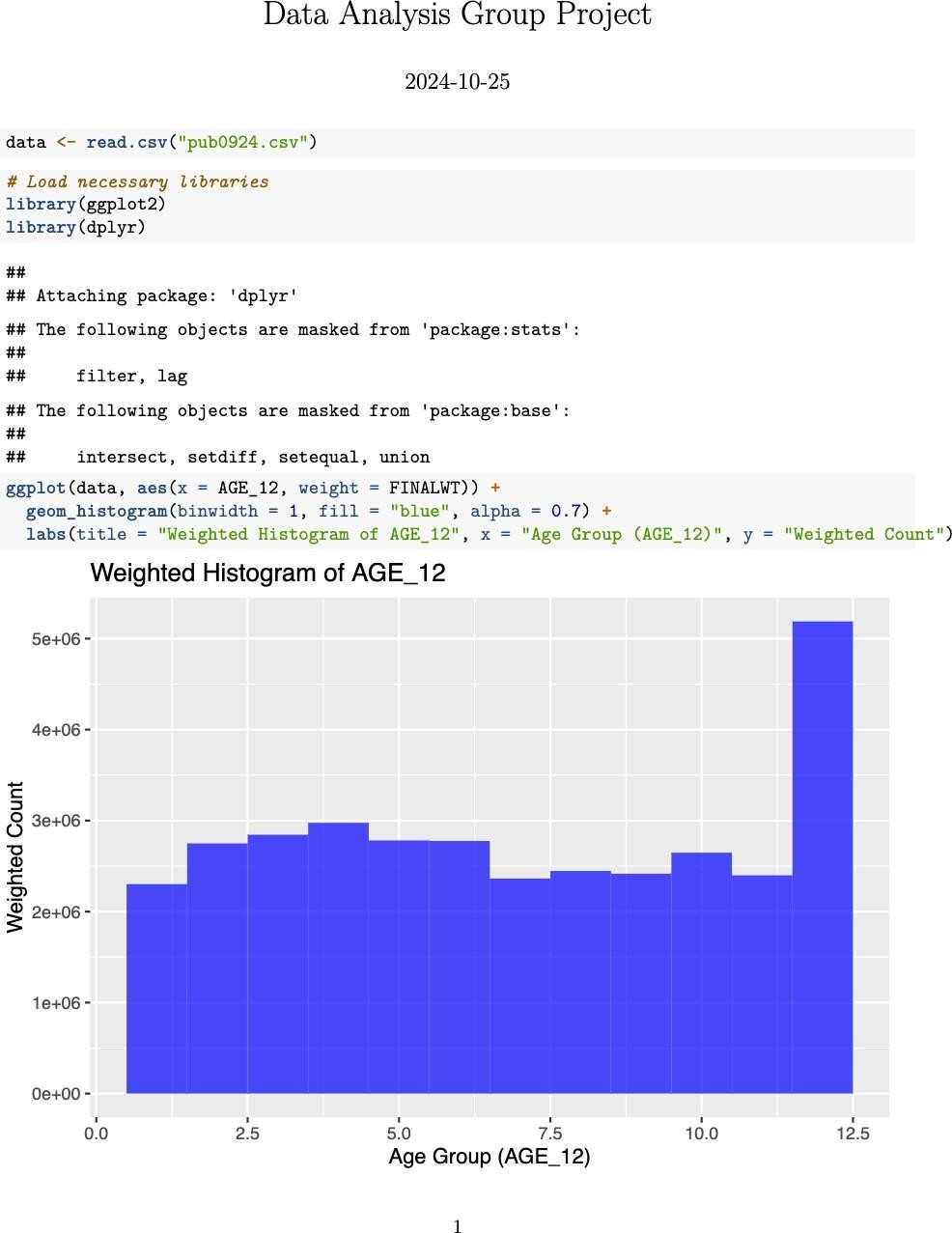

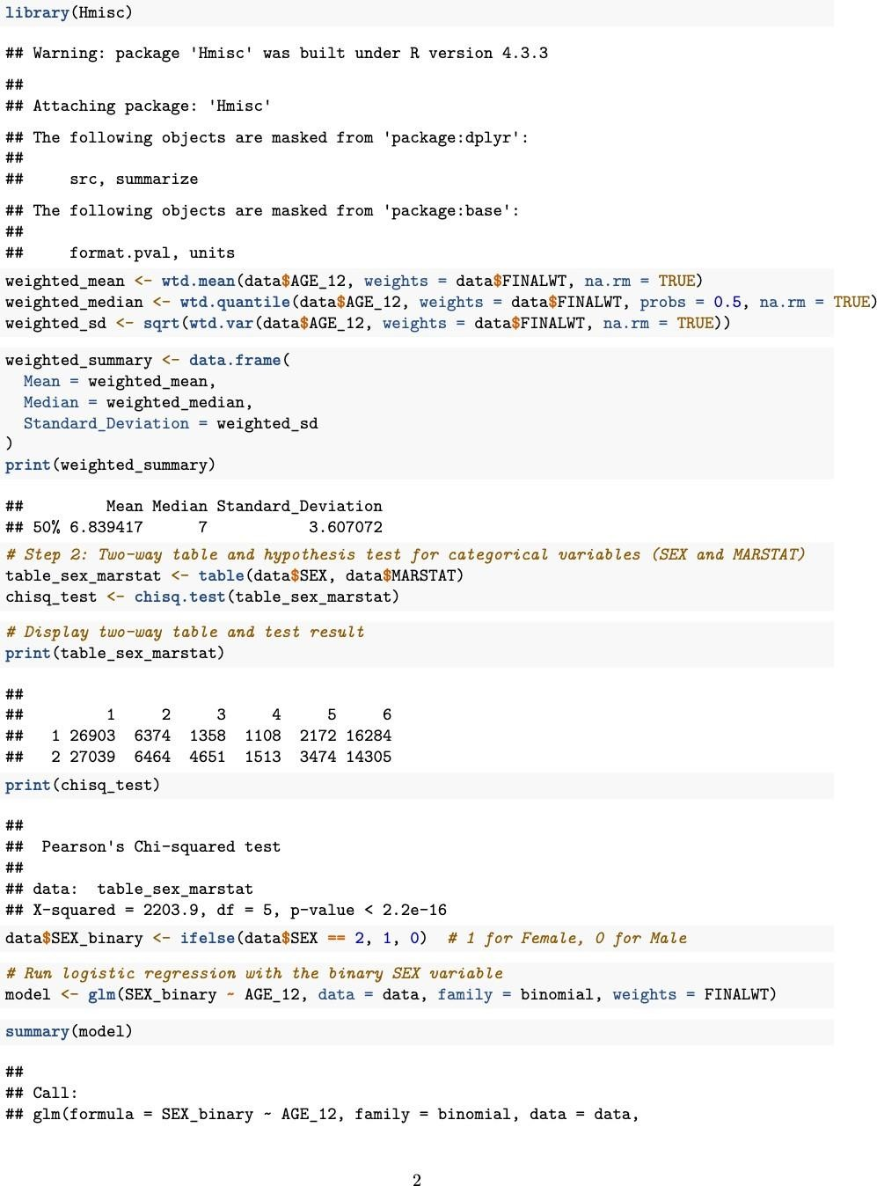
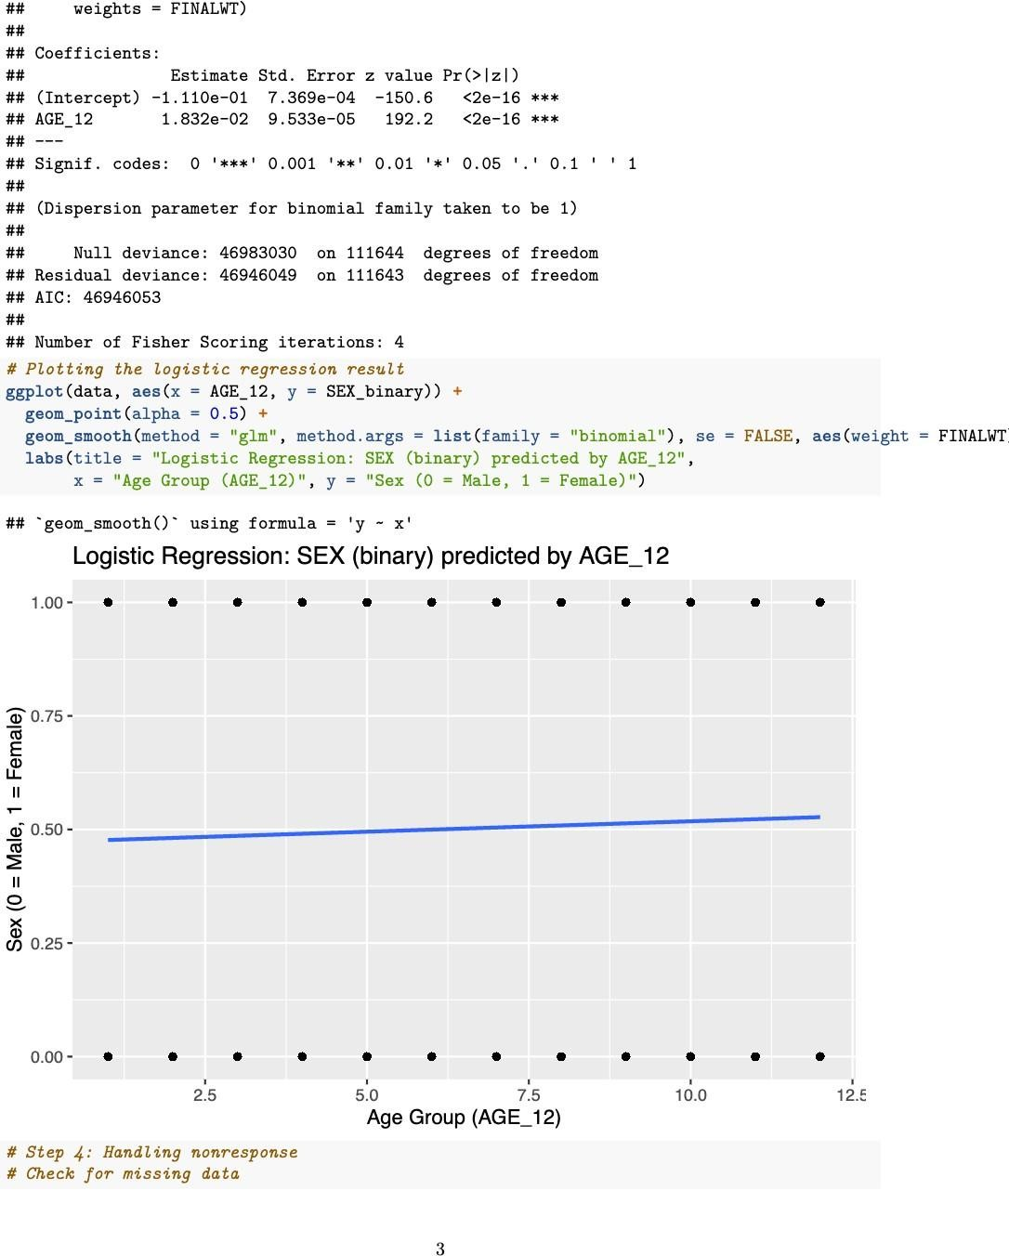

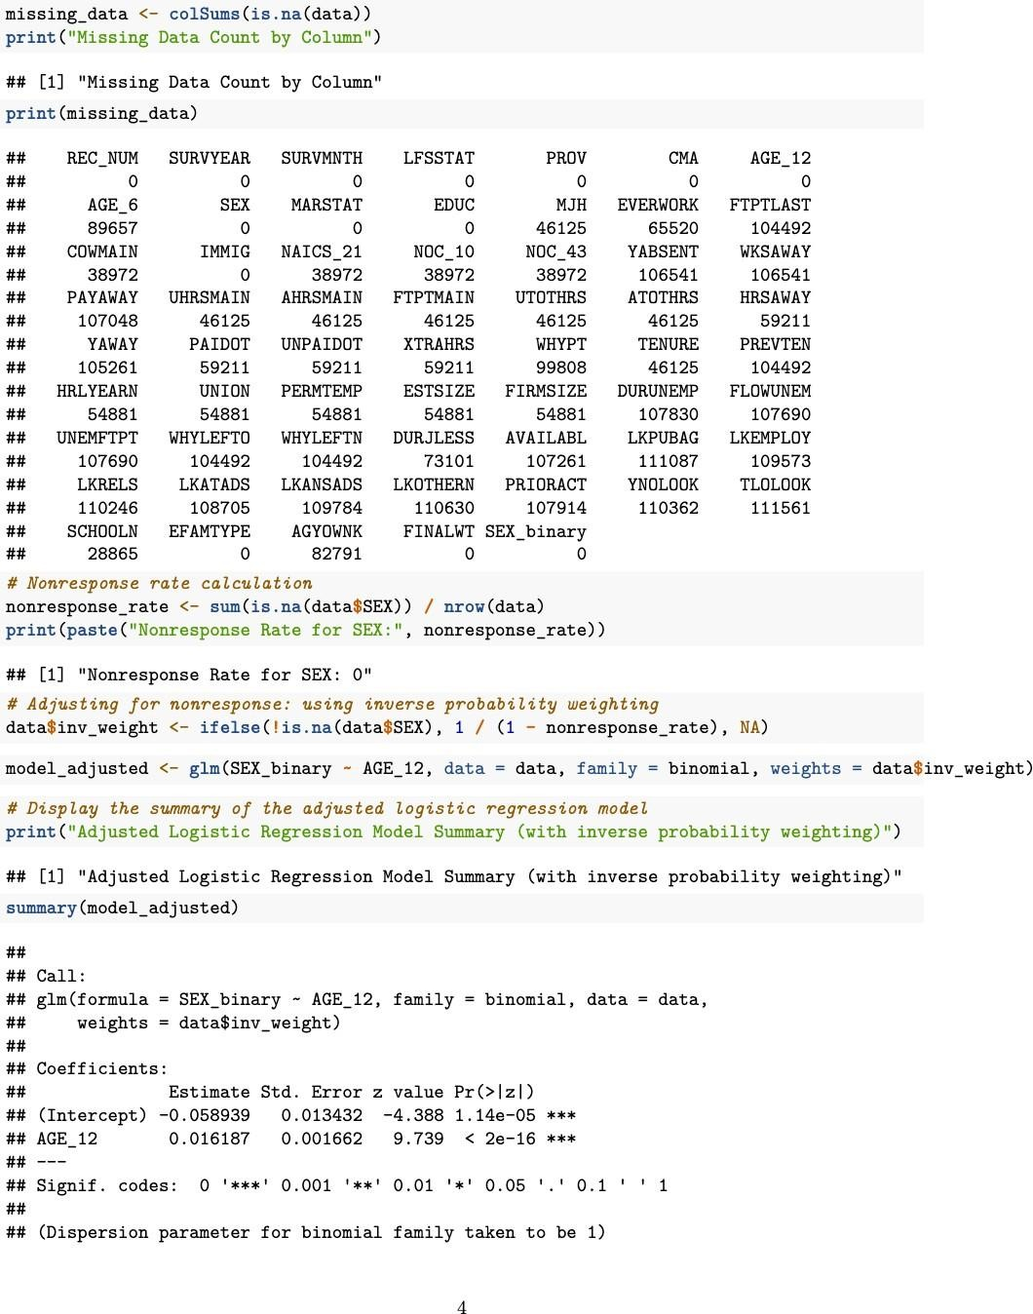



Discussion

The findings in this report reveal notable patterns in labour force participation across
Canadian provinces, based on demographic and employment-related variables from the Canadian Labour Force Survey (LFS). The analysis highlights important associations, trends, and disparities within the workforce that can inform policymakers and researchers.

Gender Disparities in Employment Status:
The chi-square test for independence between SEX (gender) and LFSSTAT (employment status) showed a significant association, suggesting that gender plays a role in determining employment status. A higher proportion of men are found in the employed category, while women have a greater representation in the "out of the labour force" category. This trend aligns with broader labour market research, which indicates that women are often more likely to face labour force withdrawal due to caregiving responsibilities or other socioeconomic factors.

Educational Attainment and Earnings:
The regression analysis demonstrated that EDUC (education level) significantly influences HRLYEARN (hourly earnings). This positive correlation suggests that higher educational qualifications are linked to increased earnings, a finding that resonates with theories on human capital, where education enhances productivity and thus earnings potential. This relationship is a key finding for labour economists and suggests that policies aimed at increasing access to higher education could play a crucial role in improving earnings potential across the labour force.

Age and Income Levels:
The positive association between AGE_12 (age group) and hourly earnings reflects an expected age-income profile in labour economics. Typically, older workers command higher wages due to accumulated experience, skills, and seniority. However, this correlation may plateau or even reverse closer to retirement age, a trend that could be explored in future analyses.

Nonresponse and Missing Data:
Nonresponse in survey data is an inherent challenge, especially when key variables like FTPTLAST (full-time or part-time status) and EVERWORK (employment history) are missing for a significant number of respondents. Although the survey addresses nonresponse through weight adjustments and calibration, missing data still introduces potential biases, particularly if nonresponse correlates with key demographic factors. Future research might benefit from sensitivity analyses or imputation techniques to evaluate the impact of missing values on survey estimates.
Policy Implications:
The findings support the need for targeted policies that address gender disparities, promote educational attainment, and ensure income growth across age groups. Policies supporting work-life balance, such as flexible work arrangements and affordable childcare, could encourage greater workforce participation among women. Similarly, expanding access to education and training opportunities for younger workers and those in low-income brackets can foster wage growth and economic stability across Canada.

Conclusion

This analysis of the Canadian Labour Force Survey offers a comprehensive view of the employment landscape, revealing how gender, education, and age influence employment status and earnings. The observed gender disparity in labour force participation suggests areas where social and economic policies could have a meaningful impact. Likewise, the strong correlation between educational attainment and earnings highlights the potential for educational investments to improve individual and national economic outcomes. Future analyses can build on these findings by integrating additional variables and conducting time-series analyses to examine labour force trends over time. Addressing the challenge of nonresponse and missing data is essential for enhancing the accuracy and reliability of survey-based inferences. Overall, the insights from this analysis contribute to a better understanding of the factors shaping labour force participation and earnings, laying the groundwork for informed policy decisions that can enhance economic equity and workforce participation.

References

- Statistics Canada. (2020). Guide to the Labour Force Survey. Statistics Canada, Catalogue no. 71-543-G. https://www150.statcan.gc.ca/n1/en/catalogue/71-543-G
- Statistics Canada. (2017). Methodology of the Canadian Labour Force Survey.
Statistics Canada, Catalogue no. 71-526-X. https://www150.statcan.gc.ca/n1/en/catalogue/71-526-X
- Statistics Canada. (2015). Chapter 6: Weighting and Estimation in Methodology of the Canadian Labour Force Survey. https://www150.statcan.gc.ca/n1/en/catalogue/71-526-X

